اشراف م/ياسمين
مشروع الشبكات
اعداد الطالب/تيسير بدر العيدروس
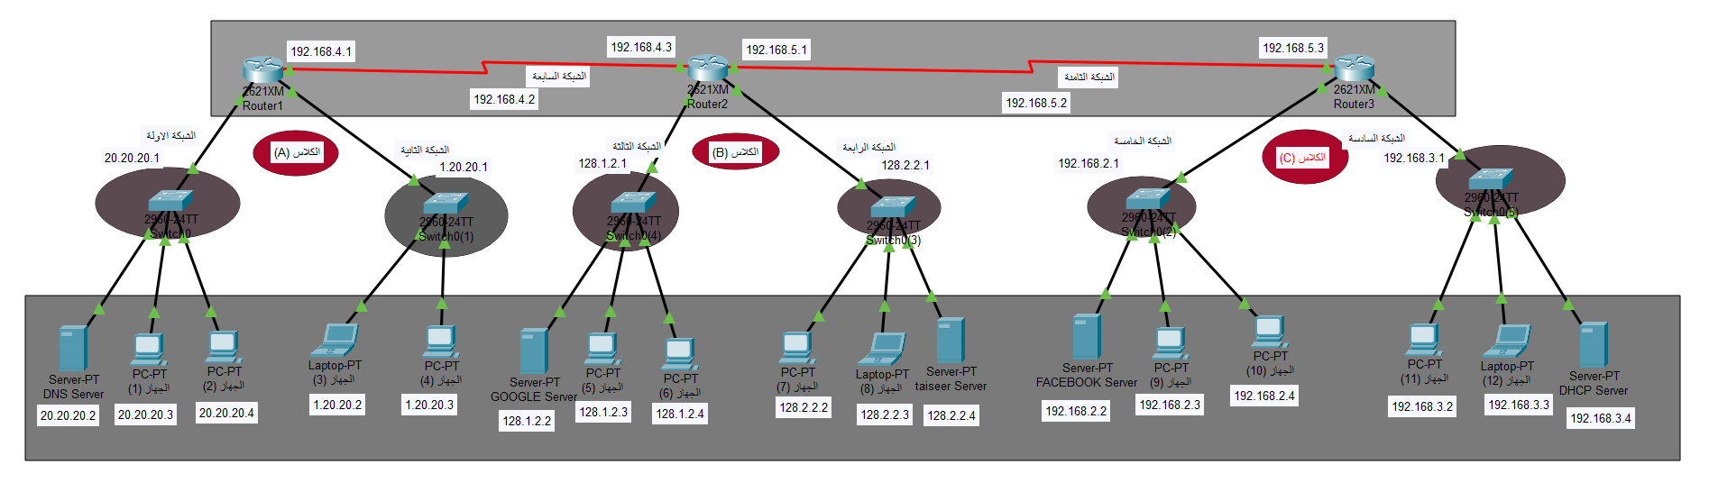
صورة المشروع
 | Network 1 | Network 2 | Network 3 | Network 4 | Network 5 | Network 6 | Network 7 | Network 8
PC 1 | 20.20.20.3 | 1.20.20.2 | 128.1.2.3 | 128.2.2.2 | 192.168.2.3 | 192.168.3.2 | --- | ---
PC 2 | 20.20.20.4 | 1.20.20.3 | 128.1.2.4 | 128.2.2.3 | 192.168.2.4 | 192.168.3.3 | --- | ---
Default Gateway | 20.20.20.1 | 1.20.20.1 | 128.1.2.1 | 128.2.2.1 | 192.168.2.1 | 192.168.3.1 | 192.168.4.2 | 192.168.5.2
Server 1 | 20.20.20.2 | --- | 128.1.2.2 | 128.2.2.4 | 192.168.2.2 | 192.168.3.4 | --- | ---
Router 1 | --- | --- | --- | --- | --- | --- | 192.168.4.1 | ---
Router 2 | --- | --- | --- | --- | --- | --- | 192.168.4.3 | 192.168.5.1
Router 3 | --- | --- | --- | --- | --- | --- | --- | 192.168.5.3

 | Router 1 |  |  | Router 2 |  |  | Router 3
Static | Network | Mask | Next Hop | Network | Mask | Next Hop | Network | Mask | Next Hop
Network 1 | --- | --- | --- | 20.20.20.1 | 255.255.255.0 | 192.168.4.3 | 20.20.20.1 | 255.255.255.0 | 192.168.5.3
Network 2 | --- | --- | --- | 1.20.20.1 | 255.255.255.0 | 192.168.4.3 | 1.20.20.1 | 255.255.255.0 | 192.168.5.3
Network 3 | 128.1.2.1 | 255.255.255.0 | 192.168.4.1 | --- | --- | --- | 128.1.2.1 | 255.255.255.0 | 192.168.5.3
Network 4 | 128.2.2.1 | 255.255.255.0 | 192.168.4.1 | --- | --- | --- | 128.2.2.1 | 255.255.255.0 | 192.168.5.3
Network 5 | 192.168.2.1 | 255.255.255.0 | 192.168.4.1 | 192.168.2.1 | 255.255.255.0 | 192.168.5.1 | --- | --- | ---
Network 6 | 192.168.3.1 | 255.255.255.0 | 192.168.4.1 | 192.168.3.1 | 255.255.255.0 | 192.168.5.1 | --- | --- | ---

